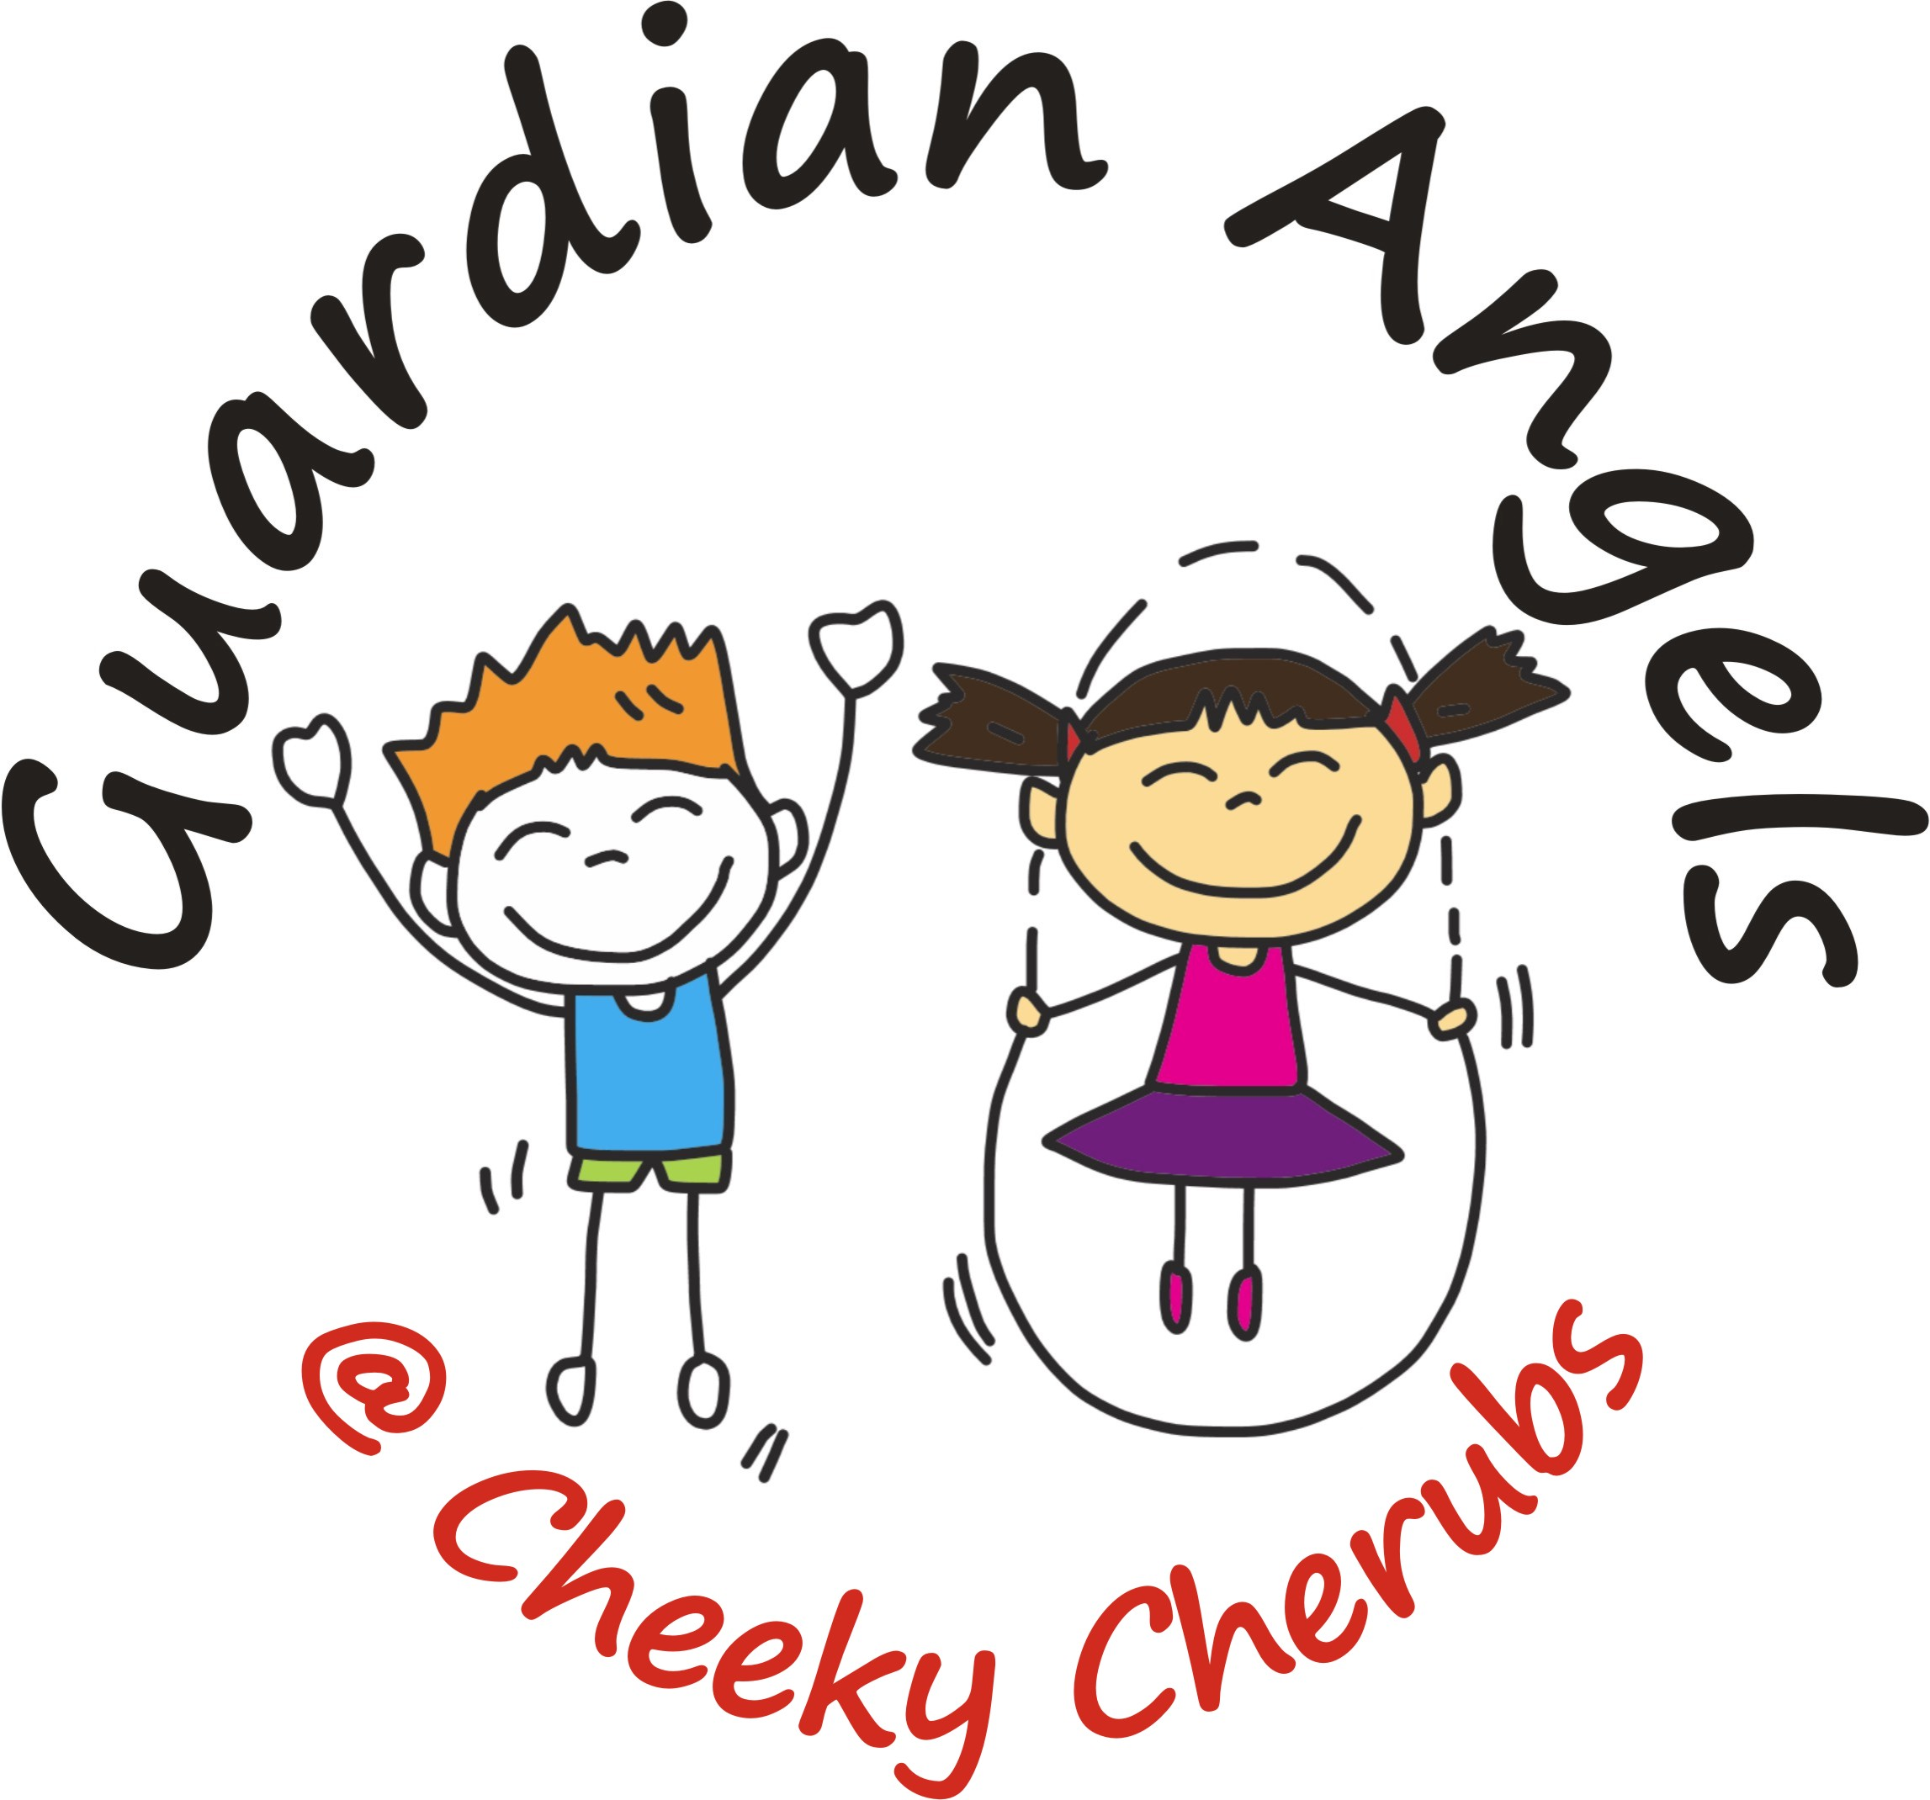
Risk
Assessments
Indoor play area, Wrap around club, holiday club and External companies.
At the Safe Play Centre we have carried out our own risk assessment to help individuals and organizations evaluate our premises and help with their own risk assessment. If we cover all of your needs in our risk assessment then you can freely download a copy for your records. We have also included a visual aid column which helps identify the areas we have assessed. 1 is low 3 is high risk. Last updated 30.11.2021
 |  |  | Risk
Area | Hazard Risk | Evaluation | 1 | 2 | 3 | Control | Visual Aid
People | Children are at risk of Abuse, Neglect, Sexual abuse and Mental abuse. | Safeguarding.  See policy  Safer Recruitment Policy | 1 |  |  | All adults working directly with the children are to have a DBS certificate, New employees should be signed up to the Updating service.  Manager to work within Safer Recruitment guidelines.  Put posters up to support parents and staff.
Entrance | Children may use as means of escape | The exit doors lead to pedestrianized shopping parade. | 1 |  |  | Must be locked during hours of childcare and key kept on members of staff for means of escape.  Children are unable to exit the play area without an adult. This is controlled by a magnetic gate which is turned on or off by a switch used by staff on the counter. The area is also monitored by CCTV | 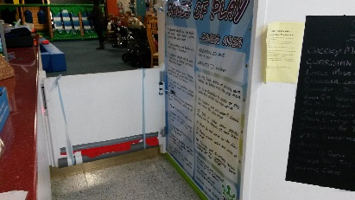  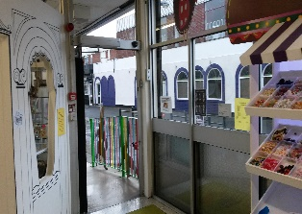
Plug Sockets | Electric shock | RoSPA recommends that all electrical equipment is stored safely away when not in use and children are supervised and warned to keep away from plug  socket outlets until they are capable of understanding the risks and are able to use them safely. 13-amp power sockets made to BS 1363 incorporate a shutter mechanism, which prevents inappropriate access to the live connectors. RoSPA therefore does not consider it necessary to recommend the use of socket covers. http://www.rospa.com/home-safety/resources/policy-statements/electricity/ |  |  |  | Children must be supervised when using electrical equipment. Ensure all sockets are in the off-switch position.
Rear Exit | Children may use as means of escape | The rear exit leads to the main car park | 1 |  |  | The door is fitted with a push bar to exit and alarmed. The bar would need an adult to push to open. The area is fitted with a sensor which bleeps when motion is activated. It is also monitored by CCTV | 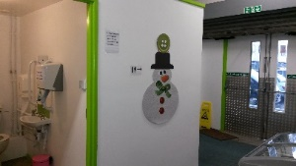
Pop Up shops area | To complete own risk assessment | Responsibility of external company. | 1 |  |  | No Climbing on the shelving, Children must be supervised in this area at all times. | 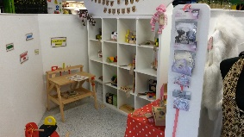
Sensory Room | Electrical equipment | The electrical equipment in the sensory room is checked regularly | 1 |  |  | Most of the electrical equipment is out of reach, except for a plug socket behind the bubble light tube. | 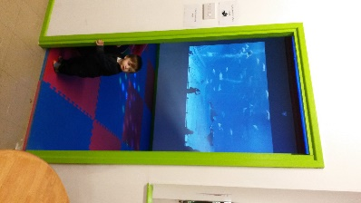
Sensory Room | Risk of Tripping | There is a 60mm step into the sensory room | 1 |  |  | Display signs warning of the step into the sensory room
High Chairs | Personal injury (Head) caused by child falling out of chair  Cuts from damaged chair/belt  Cross contamination | Checked and cleaned regularly | 1 |  |  | Children must be supervised in a high chair at all times.
Ladders/stepladders  And tressles  Ladders cont. | personal injury, from falls from ladders  Head injuries caused from tools falling from ladders | Check and report defects in the ladders |  | 2 |  | Make sure that ladders are not defective in any way.  • All ladders must be tied in top and/or bottom.  • All ladders should extend at least one metre above the landing place or the highest rung in  use, unless there are suitable handholds to provide equivalent support.  • Arrange ways of carrying tools and materials up and down so that both hands are free to  grip the ladder.  Don’t leave the ladder unsupervised whilst the play centre is open.
Play Structure
4 lane wavy slide | Physical injury from collision with other children. | Children may slide into other children at the bottom of the slide. | 1 |  |  | Children must be supervised by parents or their adult, and safety signage in place. At busy periods (over 50 children) a staff member will supervise. | 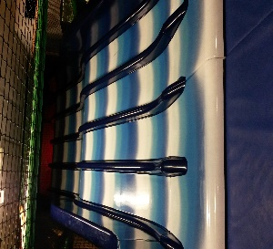
4 lane Wavy Slide | Physical injury from friction | Children may get burn like injuries due to friction from the slide. | 1 |  |  | Ask all children to wear socks, display safety signage (i.e. children must not climb the slide).  Daily check of equipment for wear and tear
Spinning disc | Injuries/cuts/lacerations/ dizziness during use caused by too many children at once/  Children spinning too fast | Children may spin into others standing at the side | 1 |  |  | Children must be supervised by parents or their adult. Observe age guidelines displayed.  Daily Check of equipment for wear and tear. | 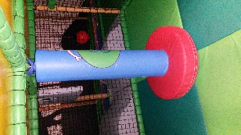
Zip wire | Physical injury from collision | Children may collide into others whilst gliding along the rail | 1 |  |  | Children must be supervised, observes signage advising of age on the apparatus.  Daily Check of equipment for wear and tear. | 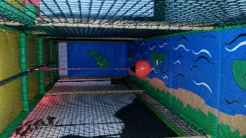
Toilet area | Hygiene | Children may contract a bug due to poor hygiene | 1 |  |  | Small Children must be supervised. Clean and adhere to cleaning schedule ensuring a clean hygienic toilet facility.  Childcare children must be supervised during public opening times. | 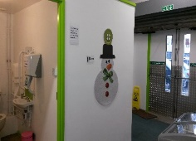
Kitchen area  Kitchen area cont. | Slips, falls, personal injury caused by to many children/horseplay/unsupervised children/  Slips/trips caused by poor repair of flooring.  Blood /body fluid contamination | Could cause, Burns, cuts, illnesses. |  |  |  | Only Trained staff to work in the kitchen.  Spillages wiped up immediately using gloves and a disinfectant.  Staff are required to wear flat sensible shoes.  Daily checks are carried out on disrepair. Any wear and tear of floor must be reported immediately  and repair works carried out and any tear should be taped over.  Any tear /disrepair to the safety net and that area must be closed off from the public at once.
Stage Area | Falling off the stage, electric shock. Disco lights get hot when lit. | Children could become excited whilst dancing etc falling off the stage. They could tamper with the equipment/wires etc causing electric shock. Children could touch the lights |  | 2 |  | Children must not go on the stage unsupervised. A sign is prominently positioned. Equipment i.e. lap top, lights etc kept out of reach when not supervised. | 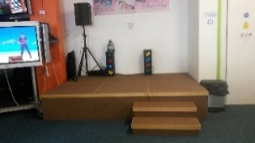
Party Room | Children may run into tables.  Safeguarding. | Tables | 1 |  |  | Children must be supervised by parents at all times. | 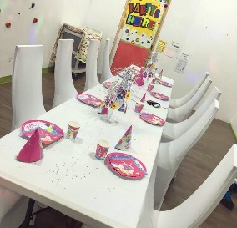
Happy Land Room | Children may collide with tables or stumble over toys etc  Causing bruises.  Cross contamination | The area has tables, shelving, chairs, changing table.  High chairs:See above  Electric cables | 1 |  |  | To keep obstacles at a minimum. Encouraging the children to tidy up and keep the area low hazard. Keep cables out of children’s reach unless 1:1 supervision.  Ensure toys and equipment are age appropriate and safe for the children’s age  Risk assess the area daily for faulty equipment and cleanliness. | 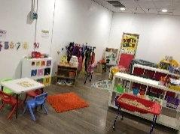
Private Hire and sleep overs | Electric shock, burns./physical injuries caused by unsupervised children/horseplay  Safety limit on number on structure is exceeded. | The use of the play centre will be unmanned by a member of staff throughout the night. |  |  |  | Conditions of Use issued at time of booking, and receipt confirmed in writing prior to hire,  specifying ratio of 1:10 helpers to children.  • Information for groups exceeding height limit prior to arrival. A full in depth explanation of fire alarm use, lighting, heating, locks, fire exits and what to do in emergency explained and contact numbers left.  • Trained, competent, mature staff to supervise and advise during use.  • All controls to be observed as normal.  • Safety signage - as already detailed elsewhere.  • Full structure and equipment check immediately after use and prior to use again by general  Public.  CCTV Monitoring through Managing director’s phone.
Wet floor | Danger of slipping | Use wet floor signs. | 1 |  |  | Mop and clear up spillage. Put wet floor sign to notify of danger
Staff | Lack of knowledge, due diligence, suitability | Use processes:  Application, Interview, induction, supervision/appraisal, DBS, training, evaluation, management checklists, staff meetings and notice board  Employee of the month incentive | 1 |  |  | Ensure all staff have the knowledge and support in order to comply with compliance policy and company procedures.  Following legislation for children at work.
Alcohol | Intoxication of individual, resulting in possible inappropriate behavior, poor decision making, decreased awareness of hazard situation. | Alcohol is not advised on the premises unless agreed by management. |  | 2 |  | If consuming alcohol the person must be over 18. There must be at least one responsible person who isn’t drinking alcohol and takes full responsibility.  People must drink responsibly.

Noise assessment Policy:
When the roof is being used it is important to be mindful of the local residents in the area. With this in mind the following must be adhered to:
Children must be supervised at all times asking them to keep noise levels down to a minimum.
No amplified music of any kind.
Music from a speaker must be at a level which is not heard out of the vicinity and must not be played after 9pm
Balls must not be thrown at the outer walls.
The roof area will be closed at 9pm.

